**Group Project #2**

Team: “Word on the Street”

Team Members: Liliana Ilut, Quentin Sloboda, Vasil Nenov, Katie Young

Project Articulation and Rationale:

Visualization of Graffiti in the City of Chicago based on complaints to 311.

Dataset Link:

<https://data.cityofchicago.org/Service-Requests/311-Service-Requests-Graffiti-Removal-Historical/hec5-y4x5/data>

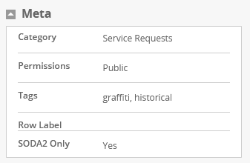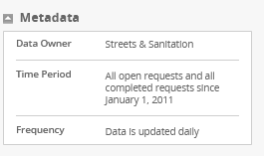

Visualizations to Inspire “Fodder”:

Viz #1

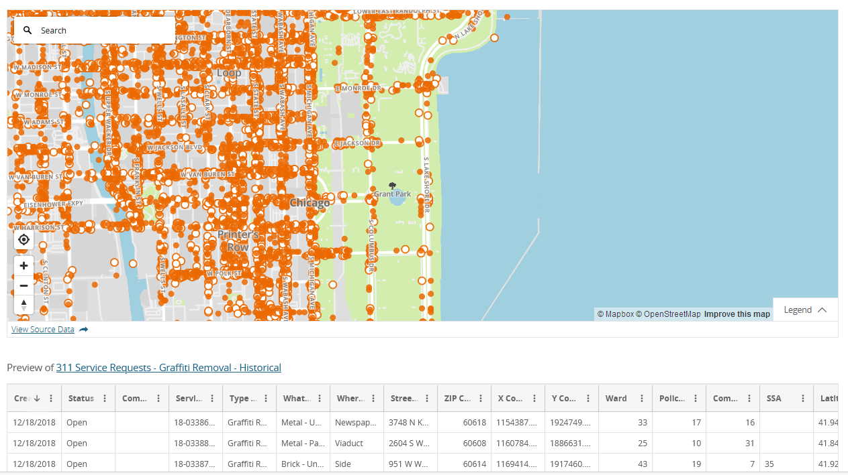

Viz #2

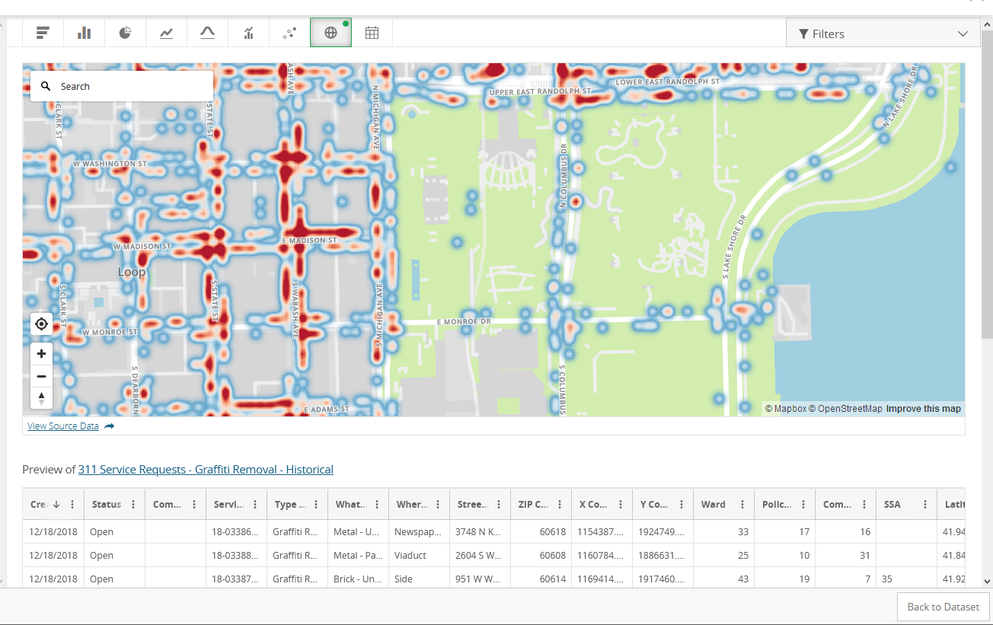

Viz #3 – Over Graffiti Removal Requests for the City of Chicago

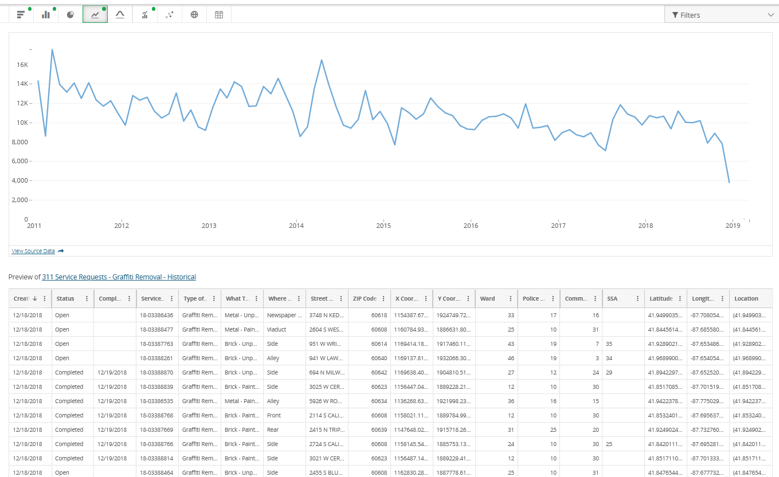

Viz #4 – Graffiti Removal Requests by Ward

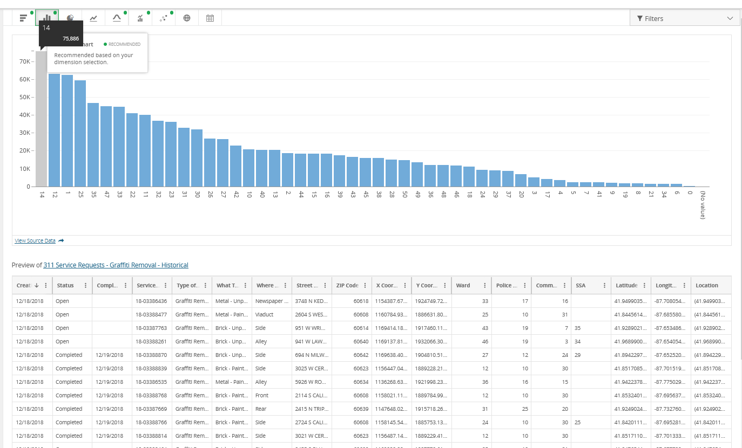

Primary GitHub Repo:

[**https://github.com/liliana-ilut/graffiti-removal**](https://github.com/liliana-ilut/graffiti-removal)